Automated Network Request Management in ServiceNow
Data Flow Diagram & User Stories
Date | 09 September 2026
Student Name | Ravipati Sri Sai Deepthi
Project Name | Automated Network Request Management in ServiceNow
Maximum Marks | 4

1. Scope of the Flow
This document describes the complete flow of the Automated Network Request Management system in ServiceNow. It covers request submission through the Service Portal, automated workflow processing, creation of the corresponding Network Database record, approval handling, decision-based flow execution, status updates, and notifications.
The flow is designed to reduce manual processing and provide a structured way to manage network-related requests from submission to final decision.

2. Process Walkthrough
- The requester opens the Network Request Catalog Item from the ServiceNow Service Portal.
- The requester enters the required network request details and submits the request.
- The submitted request triggers the configured Flow Designer workflow automatically.
- The workflow retrieves the information submitted through the catalog item.
- A corresponding Network Database record is created automatically using the submitted request details.
- The workflow sends an approval request to the configured approver for review.
- The approver reviews the request and selects either Approve or Reject.
- The workflow uses an If/Else decision to process the request based on the approval result.
- The Network Database record is updated with the appropriate approval/status information.
- A notification is sent to the relevant requester or stakeholders so that they are informed about the request outcome.
- The request details and its latest status can be viewed from the corresponding ServiceNow record.

3. Data Flow Diagram
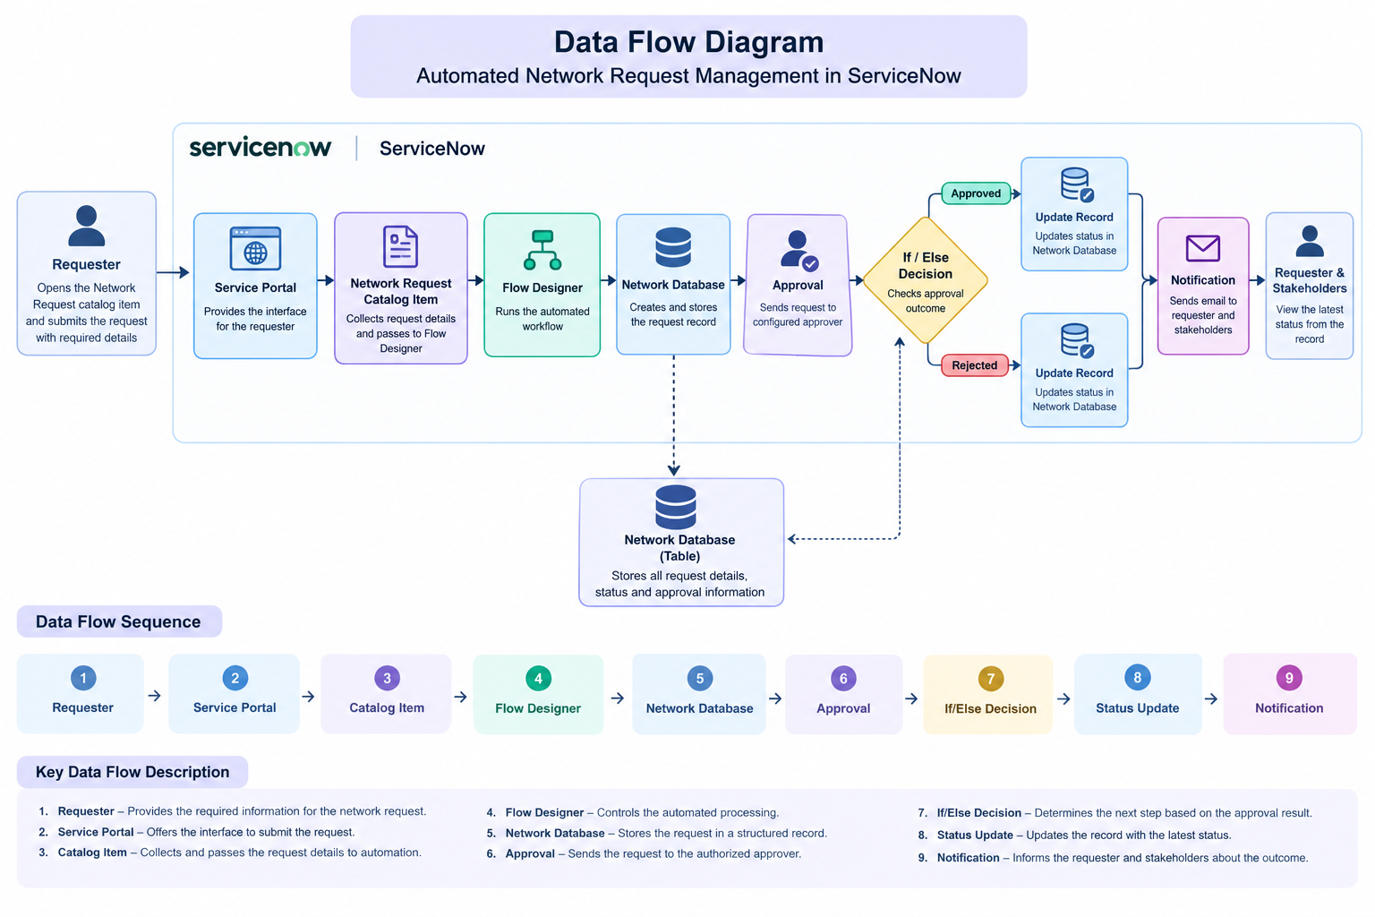

Figure 1: Data flow of the Automated Network Request Management process in ServiceNow.

4. User Stories
Stories are listed by role rather than by requirement number, with acceptance criteria folded into a single "Definition of Done" per story. All stories target Release-1.
ID | Role | Story Title | Story | Definition of Done
US-01 | Requester | Submit Network Request | As a requester, I want to access the Network Request catalog item through the Service Portal so that I can submit a network request. | The Network Request catalog item is available on the Service Portal and the request can be submitted successfully with the required information.
US-02 | Requester | Enter Request Details | As a requester, I want to provide the required details in the network request form so that my request can be processed correctly. | All configured mandatory fields are available and the form does not allow submission until the required information is provided.
US-03 | Requester | Submit Accurate Information | As a requester, I want my submitted information to be captured correctly so that the IT team receives accurate request details. | The values entered in the catalog form are passed correctly to the automated workflow without data loss.
US-04 | IT Administrator | Automate Request Processing | As an IT administrator, I want the request to trigger the configured Flow Designer automation automatically so that manual processing is reduced. | The workflow starts automatically when a network request is submitted and executes the configured actions in sequence.
US-05 | IT Administrator | Create Network Record | As an IT administrator, I want the submitted request information to be stored in the Network Database automatically so that requests are maintained in a structured record. | A Network Database record is created automatically and the relevant request information is mapped correctly.
US-06 | Approver | Review Network Request | As an approver, I want to receive and review pending network requests so that I can make an informed approval decision. | An approval request is generated for the configured approver and the request details are available for review.
US-07 | Approver | Approve or Reject Request | As an approver, I want to approve or reject a network request so that the workflow can proceed according to my decision. | The selected approval outcome is captured successfully and the workflow follows the appropriate branch.
US-08 | IT Administrator | Update Request Status | As an IT administrator, I want the Network Database record to be updated automatically after the approval decision so that the current status is always available. | The record reflects the appropriate status after the approval process is completed.
US-09 | Stakeholder | Receive Request Notification | As a stakeholder, I want to receive a notification about the request outcome so that I remain informed about the processing status. | The configured notification is triggered after the workflow reaches the notification step and is sent to the intended recipients.
US-10 | Requester | Track Request Status | As a requester, I want to view the current status of my network request so that I know whether it has been approved or rejected. | The latest request/approval status is available on the corresponding ServiceNow record.

5. Overall Workflow Summary
The Automated Network Request Management system provides an end-to-end automated process for handling network requests in ServiceNow.
Request Submission → Automated Flow → Network Record Creation → Approval → If/Else Decision → Status Update → Notification → Request Tracking
This automation minimizes manual intervention, maintains request information in a centralized record, provides an approval mechanism, and keeps users informed about the progress and outcome of their requests.

